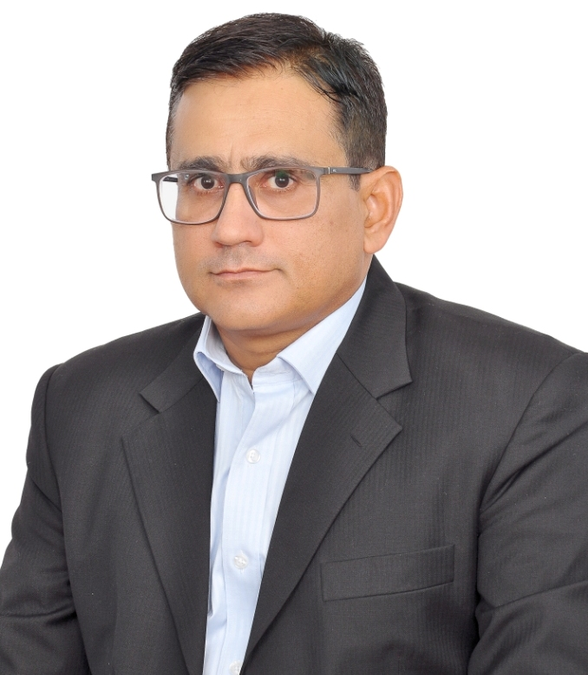
Arshad Mahmood,
SAP Sr. MM/WM Consultant

KSA: +966-501937451, 591600226
E-mail: amahmood.sap@gmail.com

PERSONAL PROFILE

Around 20+ years of functional and domain experience which includes around 7 years of SAP Experience as MM/WM as Functional Consultant and 13+ year of Strategic and Operational experience in Planning, Procurement, Warehousing, Logistics, Inventory Management, Materials Management along with SAP power user in much diversified manufacturing, utilities and retail industries.

- Five full cycle Implementation experience in SAP R/3 and SAP S4HANA MM module. Diverse experience includes involvement in all aspects of the Implementation process: Business process analysis, System configuration, Testing, Documentation, End-user training, and Production support.
- Strong background and on hand experience of physical processes and in gathering the business requirements, preparing the business workflow, design and specification documentation, testing and training material.
- Extensive experience in performing gap Analysis, preparing functional specifications, programming specification, user manuals, and troubleshooting tickets.
- Ability to take and give directions/instructions and provide assistance through completion of tasks.
- Interacting with end users right from collecting requirements to Production Support.
- Good analytical skills supported with Strong communication, presentation Skills

SAP Skill Summary
- MM/Inventory Management- Consignment, subcontracting, missing parts, movement types (GR/GI/transfer, movements), WMS, physical inventory (IM and WM), cycle counting, reservations and MRP.
- Material Management (MM): Configured in customized Purchasing, Inventory Management (IM), Physical Inventory, Valuation and Account Assignment and its functionality in SAP R/3 and SAP S4HANA, as per the business process requirements interfacing with PP and SD Module.
- Involved in the cross-functional integration of SAP-MM with other R/3 and S4HANA modules.
- Worked extensively on pricing procedures: configured condition tables, condition types, access sequences, and pricing procedures for business partner purchase and sales documents.
- Integration knowledge of MM with WM, PP, QM and SD modules
- Good knowledge in uploading data uploading Tools such as LSMW and LTMC

Business Skills
- Business Development & Gap Analysis (SAP + Core): Bridge the gap between SAP (ERP) and Business processes, Strong support of SAP Operations aligns with physical procedures, Identify, Implement & Improve the Processes and Policies which are not followed by SAP methodology.
- Analytical Skills,
- Team Building Skills,
- Problem Solving Skills and Train the trainers

Certification
- Certified in “Sourcing and Procurement (SAP S4HANA)”
- Certified by SAP, P-User ID: P2001607805 (S-User ID: S0022014866)
- SAP S4HANA (version)
- SAP ALL-IN-ONE Solutions
- In-Process “Certification in EWM SAP S4HANA (C-S4EWM_1909)”

SAP Work Experience
Obeikan Investment Group (SIG CBOB) Riyadh, KSA Oct 2020 - Present
SAP Sr. MM Consultant (SAP and Process Integration)
- Handling day to day issue, finding gap analysis from standard functionality by reviewing logistics and purchasing business processes and creating process flow using MS Visio to train the team
- Responsible for resolution of tickets and prepare necessary document as per SLA
- Investigate repetitive issues and take necessary remedial action.
- Coordinating with other consultants of FI, PP, and QM & PM for integration related issues.
- Interacting with technical team (ABAP).
- Testing of small changes in QA environment.
- Recommending team to use standard transactions and report such as ME21N to create Stock Transport Order instead of Z-transactions
- Create the Material Master Data and Vendor Master Data, and manage problem resolving processes with SAP support for the Master Data
- IM and stock taking and monitor and maintained Purchasing Document and GR.
KSB Pumps Arabia (Abunayyan Holding) Riyadh, KSA Sep 2019 – Sep 2020
SAP Support Functional MM/WM Consultant
- Provide on-site support in RTC-Quotation to PR, Purchasing, IM, Invoice Verification, Subcontracting, Bill of Materials and Warehouse Management.
- Support SAP Configuration in the area of MM master data, RFQ, PO, Pricing Procedure/Condition Type Configuration, Account Determination, Goods Movement, WM Set up, Picking/Placement Strategy Configuration and Handling Unit Management.
- Implemented and configured subcontracting, consignment and 3rd party procurement process
- Involved in design, gap analysis, configuration, authorization and conflict management in other modules including FI/CO and PP area.
- Clear all the pending transactions of WM and train the team accordingly
- Analysis the gap of current processes in WM and re-design the complete structure of WH physically, design new bins, shelves and assign to material in WM
- Help to create Material Master and Business partner Data and solve day to day issue
- Maintained and worked on inventory management with physical inventory in WM.
- Worked on PR, source lists, vendor selections, quota, RFQ, PO, terms of payments and source list determination.
- Performed gap analysis of procurement, document and implement Inbound Delivery Process, shipment process, GR & IR against shipment/Inbound
- To help PPMC department to execute MRP and update the Material Master according to requirements (Consumption base planning (Re-Order and Forecast))

Alnasser Pro. (Noortek Lighting Co.) Riyadh, KSA Mar 2015 – Sep 2019
SAP MM/WM Consultant

Project :
Client : Al Nasser Group, Riyadh, K.S.A
Project : End – to – End Implementation and Post Go-Live Support
Version : SAP S4HANA
Duration : March 2015 to Nov 2016
Scope : FI, CO, MM, WM, SD, PS, PP, QM, PM, HR and BOBJ
Role : SAP MM Consultant

Responsibilities
- Create the Material Master Data and Vendor Master Data.
- Liaison and lead discussions between business and technical team to define requirements
- Worked on purchase requisitions, source lists, vendor selections, quota, info record, request for quotations, purchase orders, terms of payments and source list determination.
- Worked with procure to pay (p2p), maintained and worked on IM with Physical Inventory
- Was involved in the updating of PO's from the legacy system the new PO's in the SAP systems.
- Defined new PO document types and configured version management for PO and PR.
- Customized IMG activities in procurement and IM processes, such as purchasing of non stock and stock materials. Material determination, sales BOM and output determination
- RFQ, Contract, Schedule Arrangements, Inbound Deliveries, GR, GI, reservation and transfer orders.
- Worked on hand in the training and support of the end users with the SAP system.
- Setting up organization structure of material management and relevant configuration like Purchase organization, valuation area plants, storage location, and warehouse structure etc.
- Finalization of material groups, purchasing groups, payment terms, Inco terms, Pricing Procedure, various number ranges of material, vendor master and purchasing and inventory documents
- Preparation of testing document and internal testing
- Preparation of master data templates for various objects like material master, vendor master.
- Pricing and its interface with Accounts Receivable and Account Determination

Project:
Client : Al Nasser Group, Riyadh, K.S.A
Project : End – to – End Implementation and Post Go-Live Support
Version : SAP S4HANA
Duration : Nov 2015 to May 2016
Scope : FI, CO, MM, WM, SD, PS, PP, QM, PM, HR and BOBJ
Role : SAP WM Consultant

Responsibilities
- Was involved in the receiving of the GR and making sure that it was assigned to the right storage location, storage bin, shelves and assigned bin to respective material
- Creation of bin in system and physically and support projects Implementation WM process
- Inventory Management, Stock Taking, physical inventory in WM, monitor and maintained Purchasing documents, GR and GI from respective bin location
Project:
Client : K- Electric (Power Generation)
Project : WM, Serialization, Split Valuation with Batch Management Implementation
Version : mySAP ECC 6.0
Duration : 2011
Role : SAP Lead MM/WM Functional Consultant
Responsibilities :
- Able to elicit user demands and translating them to data, functional, quality and usability requirements.
- Re-design and re-structure the WH physically, rack, bin to implement WM
- Implement serialization on transformer to track on pole in city
- Provide solution with split valuation and batch management for re-usable transformer and recycle copper thru sub-contracting PO with BOM in MM
Project:
Client : Nexus Automotive Pvt. Ltd. (ABACUS Consultant)
Project : End – to – End Implementation and Post Go-Live Support
Version : mySAP ECC 6.0
Duration : 2007 - 2008
Role : SAP MM Consultant

Responsibilities :
- Understand the business requirements, preparing AS-IS, and TO-BE document and sign-off with users for Business blue print document.
- Setting up organization structure of material management and relevant configuration like Purchase organization, valuation area plants, storage location, and warehouse structure etc.
- Finalization of material groups, purchasing groups, payment terms, Inco terms, Pricing Procedure.
- Finalization of various numbers ranges for material master, vendor master and all purchasing and inventory documents.
- Experience in creating test plans, test case scenarios all types of test scripts. (unit, integration, regression and UAT)
- Integration testing with other module QA, PP, SD and FI/CO.
- Preparing the user manual and imparting training to business process owners.
- Go-live preparation and post go live support.

Domain EMPLOYMENT HISTORY
- Alnasser Pro. (Noortek Lighting Co) Riyadh, KSA Mar 2013 –Feb 2015
Designation : Manager Supply Chain
- K-Electric (Abraaj Capital, Middle East) Jan 2010 – Feb 2013
Designation: Manager Supply Chain
- THAL Engineering Pvt. Ltd. (Toyota Car) Jun 2008 - Dec 2010
Designation: Manager Procurement, WH & Logistics
- Nexus Automotive Pvt. Ltd. (Chevrolet Car) Feb 2006 – May 2008
Designation: Sr. Consultant Supply Chain
- Dewan Mushtaq Group (Sugar Mills) Feb 2000 – Jan 2006
Designation: Assistant Manager SC

EDUCATION
MBA (Supply Chain& Finance) Jul 2008
Mohammad Ali Jinnah University - Pakistan
Bachelor of Mechanical Engineering Dec 1999
NED University of Engineering and Technology – Pakistan
Bachelor of Science (Mathematics & Statistics) Jun 1994
University of Karachi - Pakistan

REFERENCES
Available upon request

